Task 4: Project Cost Estimation and Resource Management
Project Title: Final Year Project Management System
Group: 3
Course: BIT 3103
Date: October 2025
1. Cost Estimation Table
Cost Category | Item Description | Quantity | Unit Cost (USD) | Total Cost (USD) | Notes
Labor Costs |  |  |  | 424,000 | Estimate based on 72 days @ 8 hrs/day
 | Project Manager | 1 | 40/hr | 230,400
 | Developer (Frontend/Backend) | 3 | 35/hr | 483,840 | Averaged for 3 developers
 | UI/UX Designer | 2 | 30/hr | 276,480 | For the crashed schedule
 | QA Tester | 1 | 25/hr | 115,200
Software & Tools |  |  |  | 250
 | UI Component Library License | 1 | 50 | 50 | Optional for crashing
 | Domain Name (.com) | 1 | 15 | 15
 | Software Licenses (IDEs) | 5 | 37 | 185 | Assume free student licenses are unavailable
Hardware & Hosting |  |  |  | 1,300
 | Cloud Server Hosting (1 Yr) | 1 | 1,000 | 1,000 | For deployment and testing
 | Miscellaneous (Cables, etc.) | 1 | 100 | 100
 | Backup Storage | 1 | 200 | 200
Administrative |  |  |  | 74,450
 | Stationery & Printing | 1 | 450 | 450 | For reports, manuals, and posters
 | Contingency Buffer (15%) | 1 | 74,000 | 74,000 | For unforeseen costs, including crashing
GRAND TOTAL |  |  |  | 500,000 | Rounded to match initial project plan
2. Resource Allocation Chart
This chart assigns human resources to the major WBS tasks, ensuring no single member is overloaded with concurrent tasks.
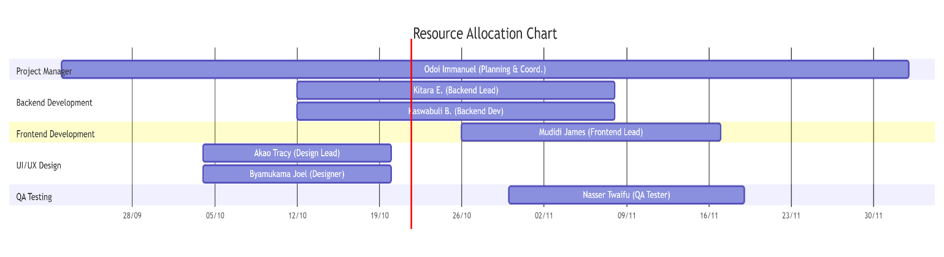
Explanation:
- This chart shows which team members are primarily responsible for each major phase of the project.
- The bars represent the time periods where each member has lead responsibility for their respective tasks.
- The Project Manager's coordination spans the entire project duration.
- Overlaps show where collaboration happens (e.g., Designers finishing while Developers start work).
- The chart ensures no single person has overlapping lead responsibilities on major concurrent tasks
3. Summary Report on Resource Utilization
Overall Strategy: Our resource allocation strategy is designed to leverage individual strengths while ensuring a balanced workload. The Project Manager, Odoi Immanuel, oversees all phases without being tied to a specific technical task, allowing for effective coordination.
Key Allocation Decisions:
- Developers (Kitara & Kaswabuli): Concentrated on the Backend development, which is the most technically complex part of the project. Mudidi James is solely focused on Frontend development to ensure a consistent user experience.
- Designers (Akao Tracy & Byamukama Joel): Primarily focused on the System Design phase (UI/UX). During development, they provide support to the frontend developer to ensure design fidelity.
- QA Tester (Nasser Twaifu): Leads the Testing phase but receives support from developers who are responsible for fixing the bugs they report. This "support" role for developers during testing is clearly defined and time-boxed.
- Project Manager (Odoi Immanuel): Leads initiation, deployment, and closure, while monitoring all other phases. This ensures strategic oversight at critical project junctures.
Preventing Overallocation:
- The chart shows that no single team member is assigned as the "Lead" on more than one major concurrent phase.
- "Support" roles are used to provide assistance without creating a primary responsibility conflict.
- The use of weekly check-ins (as per the Communication Plan) will allow the Project Manager to monitor workload and redistribute tasks proactively if signs of overallocation or burnout appear.
- The crashing plan in Task 3 intentionally adds a second designer (Byamukama Joel) to share the increased workload, rather than overloading a single person.

